16.62: If the separation of the speakers is denoted 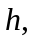the condition for destructive interference is
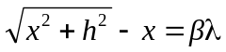,

where is an odd multiple of one-half. Adding to both sides, squaring, cancelling the 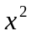 term from both sides and solving for gives

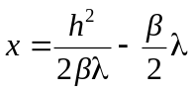.

Using 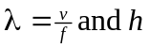from the given data yields 9.01 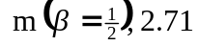 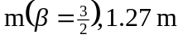
. These are the only allowable values of that give positive solutions for . (Negative values of may be physical, depending on speaker design, but in that case the difference between path lengths is 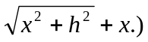 b) Repeating the above for integral values of , constructive interference occurs at 4.34 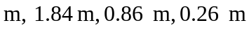. Note that these are between, but not midway between, the answers to part (a). c) If 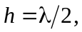 there will be destructive interference at speaker 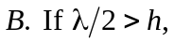the path difference can never be as large as 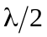. (This is also obtained from the above expression for , with 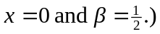 The minimum frequency is then

